**Project Design Phase-II**

**Customer journey maps**

|  |  |
| --- | --- |
| Date | 19 September 2023 |
| Team ID | NM2023TMID08200 |
| Project Name | iRevolution: A Data-driven Exploration of Apple's iPhone Impact in India |
| Maximum Marks | 4 Marks |

**Determine the requirements:**

**Data Sources:**

iPhone Sales Data: Obtain data on iPhone sales in India. This could include information on models, quantities sold, revenue generated, etc.

Market Share Data: Data on Apple's market share in the Indian smartphone market, both in terms of units sold and revenue.

**Data Cleaning and Preparation**:

Clean, structure, and format the data for easy ingestion into Tableau. This may involve tasks like handling missing values, removing duplicates, and aggregating data.

**Tableau Desktop:**

You'll need access to Tableau Desktop, which is the software used to create visualizations. You can download a trial version or obtain a license from Tableau.

**Data Connection**:

Connect Tableau to your prepared data sources. Tableau supports various data connectors, so you can import data from a variety of sources like Excel, CSV, databases, etc.

**Data Modeling**:

Depending on the complexity of your analysis, you might need to create calculated fields or perform data modeling within Tableau.

**Dashboard Design:**

Plan the layout and design of your Tableau dashboard. Consider what visualizations will best represent the data and how they will be arranged for easy consumption.

**Key Metrics and KPIs:**

Define the key performance indicators (KPIs) and metrics you want to focus on. This could include metrics like market share, revenue, user demographics, etc.

**Geographical Data (Optional):**

If you want to visualize regional impact, you might need geographic data, such as shapefiles or latitude/longitude coordinates

**User Testing**:

Test the dashboard with potential users to ensure it's intuitive and provides the insights they need.

**Documentation:**

Document the data sources, data cleaning steps, calculations, and any assumptions made during the analysis. This will help maintain the dashboard and allow others to reproduce your work.

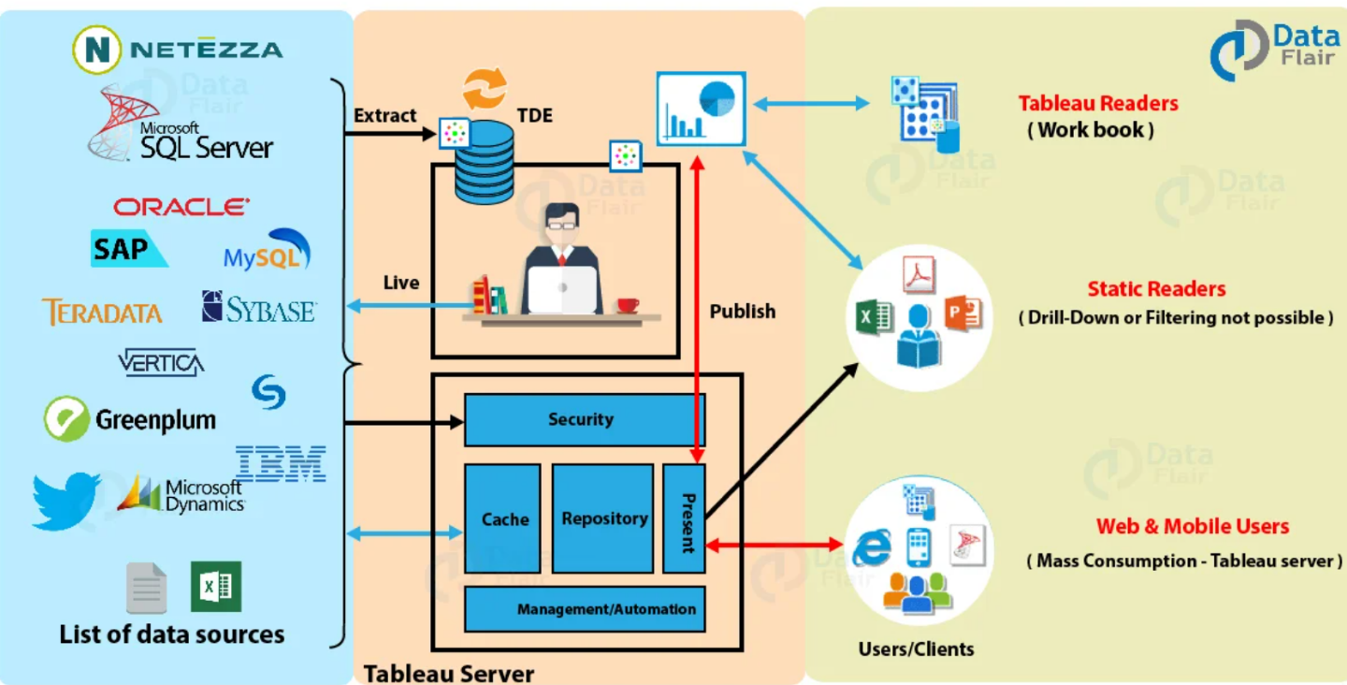

**Reference:**

https://data-flair.training/blogs/wp-content/uploads/sites/2/2019/03/Tableau-Architecture.jpg